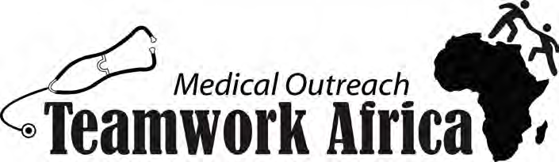

Ebola hits Liberia and Teamwork Africa

It is with great sadness that I share of two dear loses to Liberia, Teamwork Africa, and to the medical outreach work we started over a year ago. What ended in so much hope and celebration in May of this year has been over shadowed by death and uncertainty. The spring trip was a wonderful time of finding direction and making progress toward reaching the people of Liberia through medical outreach.
Nancy and Khakie were bravely treating and ministering to their countrymen when they came down with Ebola. Both are now with the Lord. Again, I can’t begin to tell you the loss this brings to many. Ebola has been hitting an already crippled healthcare system and work force without mercy. The world stands by not knowing how to help and I know I watch the news and hear news from the frontlines from Peggy and all I can feel is helpless in the battle.

Tribute to Nancy and Khakie

Nancy was a strong woman who had a passion for caring for her people. She talked passionately about the need for medical outreach in the interior villages. She helped with four of the five medical clinics on my first trip and on the training mobile medical clinic this year. She and her husband shared their home with us both trips I have been on. When I first met Nancy in April of 2013 she was an RN. When I returned in May 2014 she had graduated and was practicing as a physician’s Assistant.
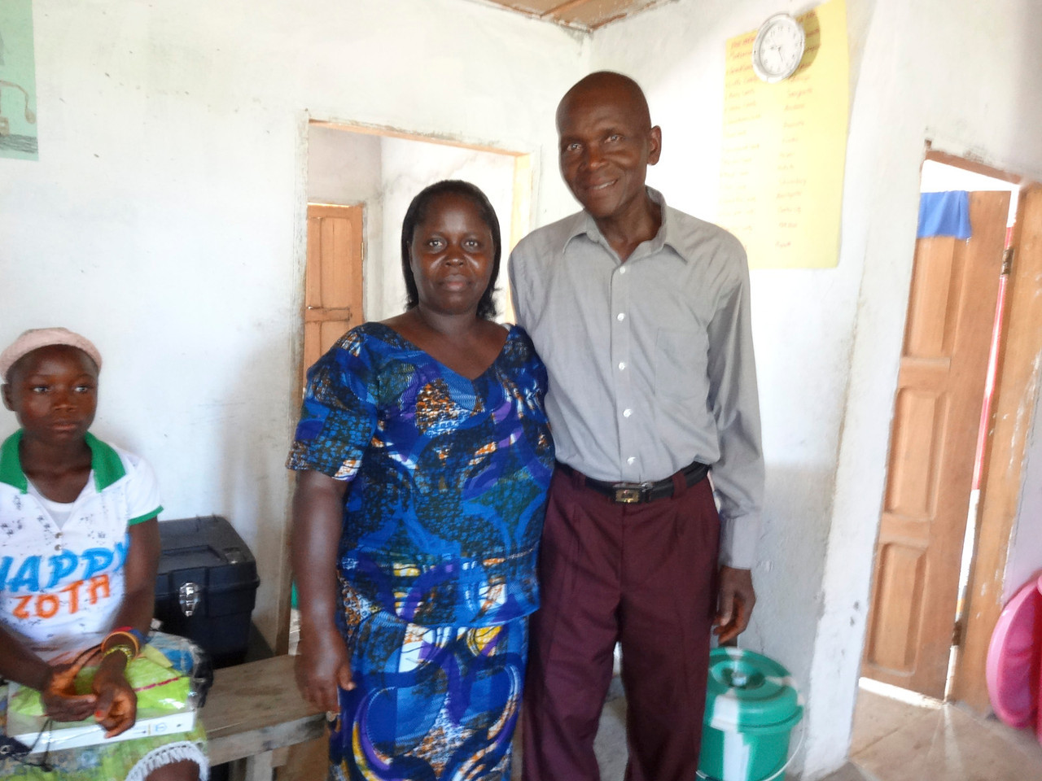

Joseph Khakie also known as Khakie, was a teacher and mentor to many. The training we did in May was a big success because of Khakie’s expertise and natural ability to teach. He quickly became a mentor for all the students. I found him a few times at the end of the day with the students continuing to teach and guide them. It was obvious from everyone who talked about Khakie the respect anyone who knew him had for him. He had big dreams about the good that could be done and for where we were going with the medical outreach portion of Teamwork Africa. There is a void that will be difficult to fill.

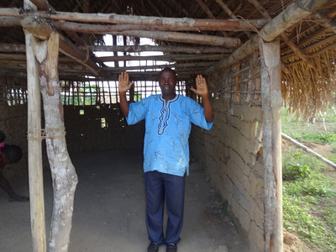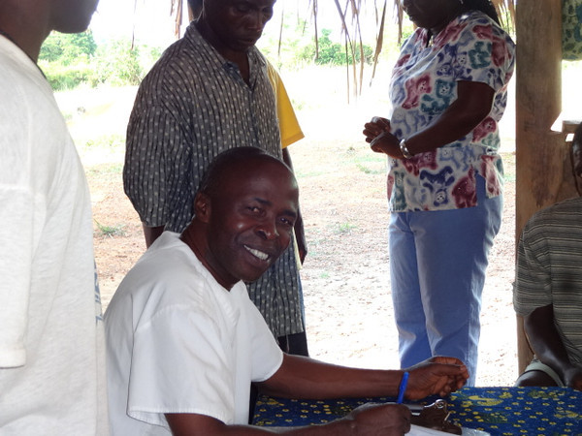

What can you do to help?

Pray!!
Pray for Oretha and her medical clinic. They are not treating Ebola patients due to lack of supplies but they are trying to treat other medical conditions as able. Ebola mimics many common illnesses in Liberia so she could very easily unintentionally come in contact with someone with Ebola. Keep her staff in prayer; Freeman, Albert, Victoria, Smart, Alice, and Anna. Pray for David that works with Teamwork Africa when he is able and has a clinic of his own.

Pray that the supplies that are ready to go from Minnesota will be able to be shipped soon. Pray that God’s will be done in and through this situation. Pray for direction for Teamwork Africa as the Ebola situation as stopped all business as usual.

Pray for the completion of the New Life Medical Center.

Give!!
There is food, medical supplies, and personal protective equipment in a Minnesota warehouse that is ready to go when funds come in to ship the supplies out. A shipment was packed and is on its way now but more is needed. A shipment costs around $7,000-$10,000 to ship the free supplies to Liberia.

The health care system that was already in shambles is going to be 100 times worse after the immediate crisis is over. We are half way done with the New Life Medical Center. There is an even more immediate need now to get the medical center complete, stocked, and staffed to help fill the void that will be left in the aftermath of this crisis.

You can give through Teamworkafrica.org.

As I have been struggling with many emotions during this time and God has brought me face to face with my grief over many loses, it is only Him I can cling to.

Thank you for letting me spend some therapeutic moments sharing with you the struggles going on in Liberia!

Amanda (Mandy) Duerr - Teamwork Africa Medical Outreach Coordinator

